Project Proposal

On

Hotel Booking Management System

Pradip Dhakal

00175009

Computing Project

Level 5 in Computing

Softwarica College of IT and E-Commerce

Kathmandu, Nepal

**1. Introduction**

**Project Introduction**

Thank you for that opportunity to submit a proposal on this website development project. Nowadays, people are too crazy about technology to the internet. People have no time to spend any things but they used devices like mobile phone, laptop and internet for online transaction. My project is about “Hotel Booking Management System”. It helps to book hotel room from online with reasonable price comparison between another hotel.

1.1 Justification of the Project

a) Background of the project

Hotel booking management system is web portal where customer can reserve room, choose room type, how many days you stay in hotel room. This website system can be easily access through browser overall work.

You can also able to subscribe their newsletter for new update and about this hotel. This website is easy to understand and easy to operate for user. For this project I have used pure PHP in programming and my SQL for storing or collection of data.

1.2 Problem Statement

Nowadays, people have no time for queues for long time at hotel counters and lots of work are done in paper. Customer cannot get room with reasonable price. So, this system will help to move digital and user can able to book hotel room before someone reserved. If you will find your best room with affordable price, you feel comfortable to stay at this hotel room.

I think this system will overcome all this problem. This system provides to book hotel room with reasonable price, time reduce, customer experience in hotel.

1.3 Description of the project

1.3.1 Features of the project

Some features of this website are:

* User can register their information to book room

User can register their information and book room from anywhere through internet.

* User can book types of room which is available

User can able to book what type of room have currently available from anywhere and anytime with type of rooms.

* User can subscribe their newsletter

User can get notification or new update about hotel like message and hotel manager call user for information about the service of the hotel.

* User can rate room

What user think about hotel services and what type of features they want from this hotel.

* User can view their user experience

Customer can share their how they feel about that hotel room and share their experience in hotel services.

* User can view their hotel gallery

Customer can able to view about hotel galley.

* Admin can add, update and delete about which room are available or not.

Admin only can able to add, update and delete which room are available in that time or not and what price is allocated that room in hotel.

1.4 Overview of the project

This system helps people to know about their services, user experiences at hotel, time and money also save comparison between another hotel.

2. Project Scope

2.1 Scope

Hotel booking management system store user information in database like types of room, reasonable price, what number of days user can stay at hotel room. This system helps to reduce lots of paperwork. It also helps to increase user satisfaction about that hotel.

Limitation

* In this system user cannot be able to add, update or delete about hotel information,
* This server no faster and it may take too much time to load the system because it is not too large server.

2.2 Aims

The main aims of this project are

* To increase user satisfaction about that hotel,
* User can able to get fast and quality services from that hotel,
* Customer can easily access website from anywhere and anytime with the help of internet connection

Objectives

The main objectives of this hotel booking management system are:

* To manage all booking rooms, time, price etc
* It helps to reduce manual work in paper,
* Helps to increase hotel reputation or customer satisfaction,
* The bill will be generated by digitally,
* The calculation time will be saved.

3) Development Methodology

In development methodology there are agile method and Waterfall Methodology. For this hotel booking management system, I have used waterfall model for this project. Because this project is small and it does not take long time to developed. That’s why I choose waterfall model is best for small project and it takes no longer time to develop system. Agile methodology is best for large project. That’s why I’m not using this method for this project.

3.1 Waterfall Model

The waterfall model was the first process model to be introduced. This model is step by step process to complete one to another step. It helps to create easy, simple and understanding to use. In this model was derived in different stages are requirement analysis, design, implementation and testing.

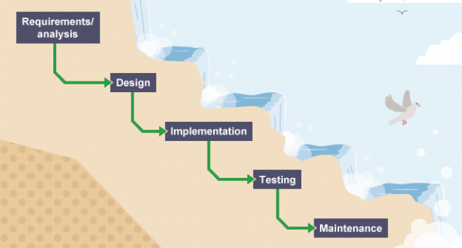

In first step analysis, we need to identify the requirement and collect it and document on it. Next step, system design with the help of collected requirement and analysis from previous steps. Then system design to we need to write a code about that system called implementation phrase. After implementation, testing phase which is called as unit testing. This step we need to find out bugs and solve on it. At the last step maintenance, it helps to maintained the system after the deployment.

3.2 Design Pattern

The design pattern is a reusable or repeatable solution for commonly occurring problem in system development. A design pattern is not complete design to transformed directly into code. For this project, I decided to use MVC pattern.

3.2.1 MVC Pattern

I have used MVC Pattern for this project because it helps to separate code in Model, View and Controller with clear and easy to understand pattern. The MVC Patter are:

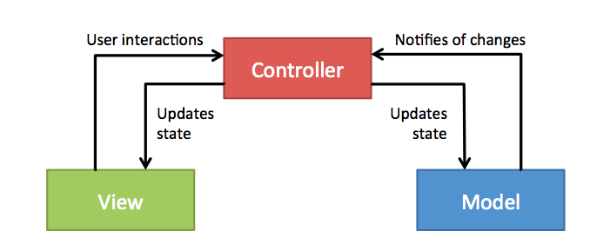

Model: it helps to handles the logical part of the system.

View: It handles presentation of the model or user interface of logic of application.

Controller: It helps to handles the user to interact with the model.

3.3 System Architecture

The system architectures is the process where the concepts that will be the support of the definite system are established and it helps to show the relationship between the system component. For this project, I have used 3 tier architectures diagram in below:

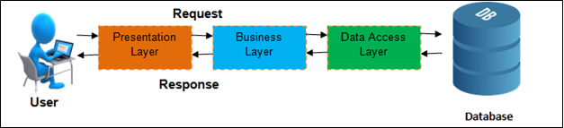

Presentation Layer: This is the top level and displays information related to services available on a website. it communicates with other tires to sending results to the browser and other in network.

Business Layer: This layer also called middle layer or logical tier or business logic is pulled from the presentation tier. It helps to controls functionality of application by processing.

Data access layer: This layer is independent with application and business logic. In this layer is used for storing data and information in server also data are retrieved from here.

4 Project Plan-work Breakdown Structure

4.1 Work Breakdown Structure

The Work breakdown structure is the foundation for project planning and control. It is the process of dividing the huge project into small number of tasks to involving in work and cost estimates, schedule information, actual work effort/ cost expenditure. It helps to save time in system development.

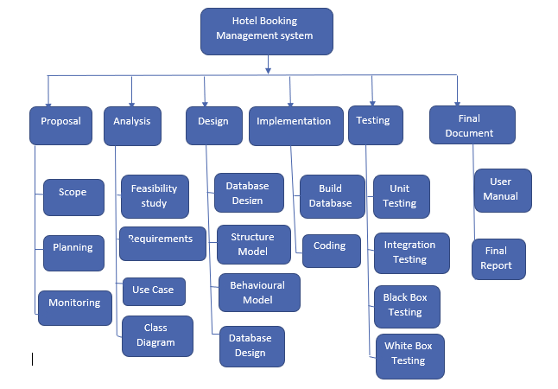

|  |  |  |
| --- | --- | --- |
| WBS | Task Name | Days |
| 0 | Hotel Booking Management System | 108 Days |
| 1  1.1  1.2  1.3 | Proposal  Scope  Planning  Monitoring | 16  5  8  3 |
| 2  2.1  2.2  2.3  2.4 | Analysis  Feasibility Study  Requirement  Use case  Class Diagram | 28  8  8  5  7 |
| 3  3.1  3.2  3.3  3.4 | Design  Database Design  Structural Model  Behavioural Model  UI Design | 26  7  6  6  7 |
| 4  4.1  4.2 | Implementation  Build Database  Coding | 20  5  15 |
| 5  5.1  5.2  5.3  5.4 | Testing  Unit Testing  Whitebox Testing  Blackbox Testing  Integration Testing | 7  2  2  2  1 |
| 6  6.1  6.2 | Final Documentation  User Manual  Final Report | 11  5  6 |

4.2 Milestones

|  |  |  |  |
| --- | --- | --- | --- |
| Title | Start | Deadline | No. of Days |
| Proposal | 25th March | 9th April | 16 Days |
| Analysis | 10th April | 8th May | 28 Days |
| Design | 9th May | 3rd June | 26 Days |
| Implementation | 4th June | 24th June | 20 Days |
| Testing | 25th June | 1st July | 7 Days |
| Final Documentation | 2nd July | 12th July | 11 Days |

Description of Milestones

Proposal

For this task, 16 days are allocated, are divided into 3 parts which are scope for 5 days, planning for 8 days and monitoring and controlling for 3 days.

Analysis

For this task, 28 days are allocated, divided into 4 parts which are feasibility study for 8 days, requirement for 8 days, use case for 5 days and class diagram for 7 days.

Design

For this task, 26 days are allocated, divided into 4 parts which are database design for 7 days, structure model for 6 days, behavioural model for 6 days and UI Design for 7 days.

Implementation

For this task, 20 days are allocated, divided into 2 parts which are build database for 5 days and coding part for 15 days.

Testing

Testing 7 days are allocated where unit testing for 2 days, white box testing for 2 days, black box testing for 2 days and integration testing for 1 days.

Final Documentation

Total 11 days are allocated for final documentation in which user manual for 5 days and final report for 6 days.

4.3 Scheduling: Gantt Chart

A Gantt chart is a useful graphical tool which show activities or task performed against time. It helps to show working plan in break into part to part in different pieces. It is commonly used for tracking project schedules. In this project Gantt chart help to show start date and deadline date. So, at below show this project Gantt chart, it is easy to understanding.

5.Risk Management

During this project, there are various risks happen while doing this problem. Risk management is the process of classifying the possible risks and controlling threats of the project. In this project, some of the solution to control risks are listed below. (TechTarget, 2019).

* Day to day should be backup data or information,
* Time to time maintain resources,
* Estimate proper budget for project,
* Design attractive interface.

Impact= likelihood * consequence

Risk Likelihood values are shown as follows

|  |  |
| --- | --- |
| Likelihood | Value |
| Low | 1 |
| Medium | 2 |
| High | 3 |

Risk Consequence values are shown below:

|  |  |
| --- | --- |
| Consequence | value |
| Very low | 1 |
| Low | 2 |
| Medium | 3 |
| High | 4 |
| Very High | 5 |

Risk Consequences values are shown below:

|  |  |  |  |  |  |
| --- | --- | --- | --- | --- | --- |
| S. No | Risks | Likelihood | Consequence | Impact | Solution |
| 1. | System Failure | 1 | 3 | 3 | Sometime system does not work properly it shows error, we need to check and maintain system time to time. |
| 2. | Old technology | 2 | 3 | 6 | Technology should be use new and advanced for to get better performance. |
| 3. | Network problem | 2 | 2 | 4 | If sometime one network slow down then we need to another network system for backup |
| 4. | Bad Design | 2 | 4 | 8 | For create good design, give staff training about it. |
| 5. | Inside theft | 2 | 4 | 8 | Increase user satisfaction and monitoring staff activities. |
| 6. | Requirements are incomplete | 2 | 4 | 8 | Requirement analysis and planning should be properly done. |
| 7. | Hard disk crack | 2 | 3 | 6 | we need to do backup plan for save data. |

6. Configuration Management

A configuration management system is used to keep track hardware, software and information of the system. it includes software versions and updates installed on computer system. Tt helps to manage all necessary data kept current and accurate. This process configures the product meets the detailed performance principles of the system.

